37.40: 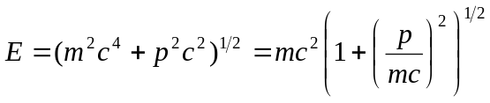
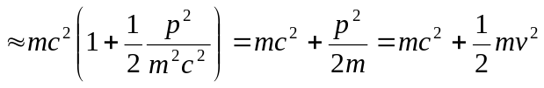
the sum of the rest mass energy and the classical kinetic energy.

